Name________________________
Date_________________________

Final Exam: Introduction to Philosophy
The final exam is a series of short essay questions arranged by author or theme. Students may omit any one question of their own choosing. (There is no extra credit for answering the 11th question and I will grade the first 10 questions I see.) Students will ultimately answer ten short essay questions worth ten points each.

- Present Aristotle’s Doctrine of Mean. Students must develop at a minimum of two virtues to present the point and adequately develop the necessary condition for virtue.

First, avoiding excesses is one of the essential states for getting a specific dispositional mean-condition. The excesses should be avoided for the correct purposes, to upheld morality. Next, how the excesses are best prevented is not as simple as the range model proposes. Individuals do not efficiently avoid the excesses simply by looking for control in everything. Individuals do not evade the excesses simply by targeting to get an answer within a given range on or even many one-dimensional ranges, hard as it may be. What is commendable or excellent does usually lie within the range, however, it's commendably or excellence entails of more its position on different continua.

- Recount the three kinds of friendships discussed by Aristotle in the Nicomachean Ethics. Students should list two characteristics or qualities of each and then state the key difference between good (virtuous) friendship and the other two.
Friendships of utility that exists there are mutual usefulness between two individuals. For instance, having a friendship with the neighbor because he helps take care of the young sibling and in turn, you take for his children to school. Secondly, friendships of pleasure that occur between those individuals who enjoy the company and you. Thirdly, friendships of the good that is grounded on mutual admiration and respect. These relationships take a longer time to develop unlike the other two types nevertheless they are also more enduring and powerful. Friendship based on both utility and pleasure begins fast and ends fast but friendship based on good takes time to begin.
- According to Aristotle, what is the aim of political science and how does it try to achieve this end? (Students may include an image as part of the answer but must explain and develop it in prose.)
As per Aristotle political science entails the other sciences such as military and household management science which at the end satisfies the human good. Despite the conclusion is similar for the city-state and an individual that end of the city-state appears at any mean greater as well as more complete to preserve and attain.
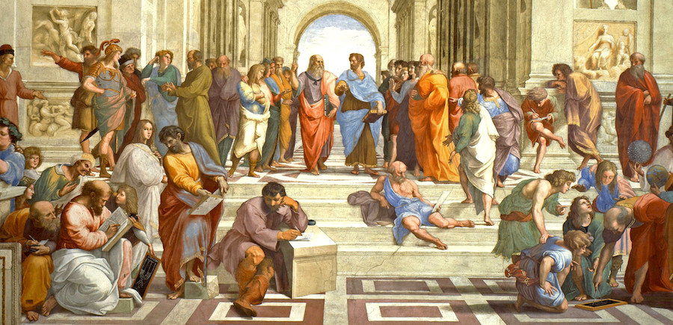
Even if it is possible to attain political science at an individual level, it is significant to apply at the city-state or at the national level. Political science has more authority than the other sciences and it controls the other sciences in general in satisfying the end.
- Present Anselm’s argument for the existence of God found in the Proslogion.
Anselm implies to display that it remains self-inconsistent to negate that there is a supreme possible being. Therefore, on this general supposition of debate, it is a certainty that such creatures exist; and this supreme is the God of customary Western theism. The present debate purports that revolutionary options may be rejected however, incomplete virtues could be entrusted to polite unconsciousness. The current discovery of the existence of a supreme being will require subjection to the reasoning of the power behind its existence.
- Present two of the five ways that Aquinas argues God’s existence can be proven in the Summa Theologica.
The first is the debate from motion. It is evidence and certain to the intellects that in the globe there are things in motion. Therefore, the things in motion that are put in motion by others, for nothing could be in movement except it remains towards which it remains in motion; while a thing travels so long it is in motion. The second argument is from the kind of competent cause. In the globe of intellect individuals find, there exists an order of competent causes. There exists no instance recognized neither is it, undeniably, probable in where things are found to have the competent causes of themselves; for them would be earlier to themselves, which is unbearable.
- Present Descartes’ proof for the existence of God found in Meditation III. (Students may present the argument in disjunctive form as part of the answer but must also explain and develop the argument in prose.)
Among the promises of Descartes' form of the ontological understanding includes its simplicity. Undeniably, it states like the evidence of an instinct than an official proof. Descartes highlights the simplicity through the demonstration by relating it to the manner in which individuals create fundamental truths in geometry and arithmetic, like the number four is even or that the summation of the angles of the triangle is equivalent to the total of two right angles. Individuals intuit such facts directly by reviewing the distinct and clear concepts of the triangle and number four. Therefore, similarly, individuals are capable to achieve information about God's presence simply by getting that essential presence is comprised of the distinct and clear impression of a superlatively perfect being.
- Explain Pascal’s Wager in prose and then defend the conclusion using the utility matrix method.
Pascal debates that the rational person must live like God exist and should ensure he or she believes in God. In case God does not exist, such an individual will have a limited loss to some luxury and pleasures, while he stands to get unlimited benefits as exemplified by infinity in Heaven and prevent immeasurable harm in eternity and Hell. Pascal's Wager believed in the existence of the Christian God, although related opinions have happened in other spiritual traditions. Pascal tells individuals to examine humankind's situation, where the actions may be colossally significant but the appreciation of those concerns flawed. Individuals are supposed to discern greatly through reasoning instead of staying minus thinking and appreciating the existence of God.
- According to Descartes’ Meditation I, can you be sure that you are right now taking your final exam? Why or why not? (2 reasons) And, with respect to Meditation II, can a person be absolutely certain about anything? Why or why not?
I am sure taking the final exams through Descartes’s medication that has made me believe in the existence of God. Descartes shapes some of the objections to the argument and declares that his opponents generally overlooked his chains of rationality and only revolted his conclusions. As per meditation II, it is not possible to be certain about a given thing because the mind remains a virtuously thinking thing. Descartes acknowledges, nevertheless, that although what he sees with his intellects may be untrue, he cannot negate that he observes. Therefore the human mind remains able of both perception and thought and one has to put it to thinking. Subsequently, the kind of thinking will depend on the situation and the rational capacity of that individual deliberating over the matter.

- According to Descartes’ Meditation IV, how is human error possible and what must be done to avoid making mistakes? (Students may include an image as part of this answer, but must explain and develop that image in prose.)
Human mistake is possible as Descartes tells that although he was God made, he is not like God, however instead something in-between nothingness and God, or between non-being and Supreme Being. As an intermediary between nothingness and God, the human fault does not originate from God: it is a flaw that originates from existing as an imperfect existence. Descartes stares carefully at himself to define the kind of human fault and finds that it relies on two coexisting causes: the ability of awareness that is within his body and the freedom of choice and liberty of the willpower.
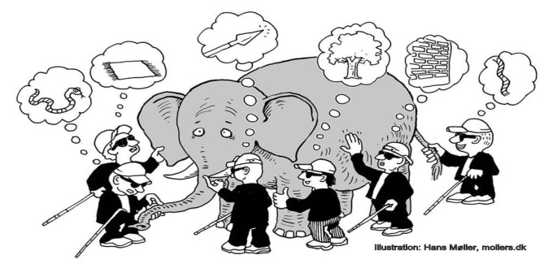

- In A Treatise of Human Nature, how does Hume account for the origin of ideas and how does his account differ from Plato’s? And, what are some of the inherent limitations for language implied in Hume’s account?
Human beings utilize different reason that creates their thinking concepts. Hume questions on what basis that makes individuals come to believe about the unseen on the foundation of inductive implications. He brings a dispute in the nature of a predicament which seems to dominate the likelihood of any thinking from the pieces of evidence to the inference of an inductive conclusion. There are, two likely forms of arguments including probable and demonstrative, nevertheless neither will work. Demonstrative thinking develops the wrong form of deduction, and a likely debate could be circular. For that reason, for Hume, the challenge is of how to enlighten why individuals develop any deductions that go past the occurrences of which individuals have had involvement.

References
https://www.youtube.com/watch?v=nPRTh_HLgUA&feature=youtu.be

